**MultilayerPerceptronClassifier**

We applied the MultilayerPerceptronClassifier model (machine learning algorithm that belongs to the family of artificial neural networks) to the data with ParamGrid, and we got the following results.

F1 Score of Worst Model: 0.4961894591743432

It was taking too long to execute in the pipeline thus we ran it explicitly in the end. Anyways, the model was not a good fit as it gave us only ~0.49 F1 score. Thus, we kept Logistic, Random Forest, and GBT only in the pipeline (among which Logistic is the worst).

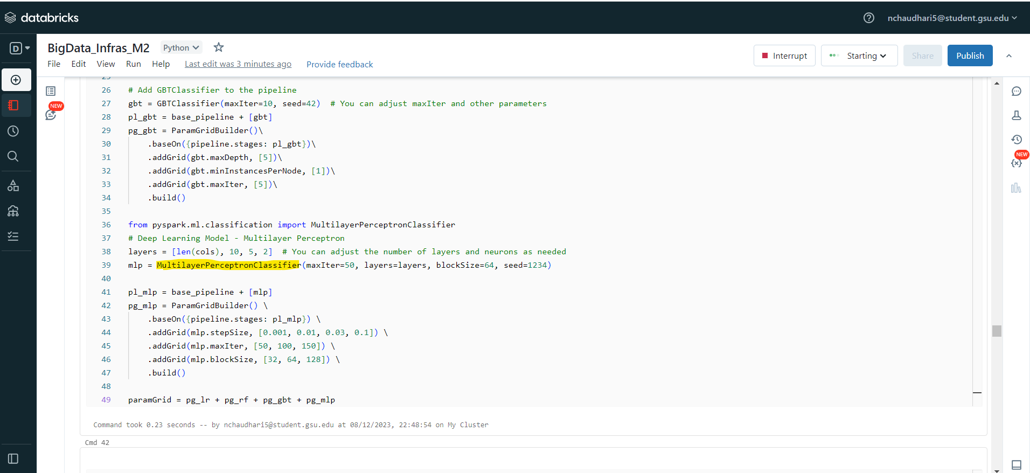

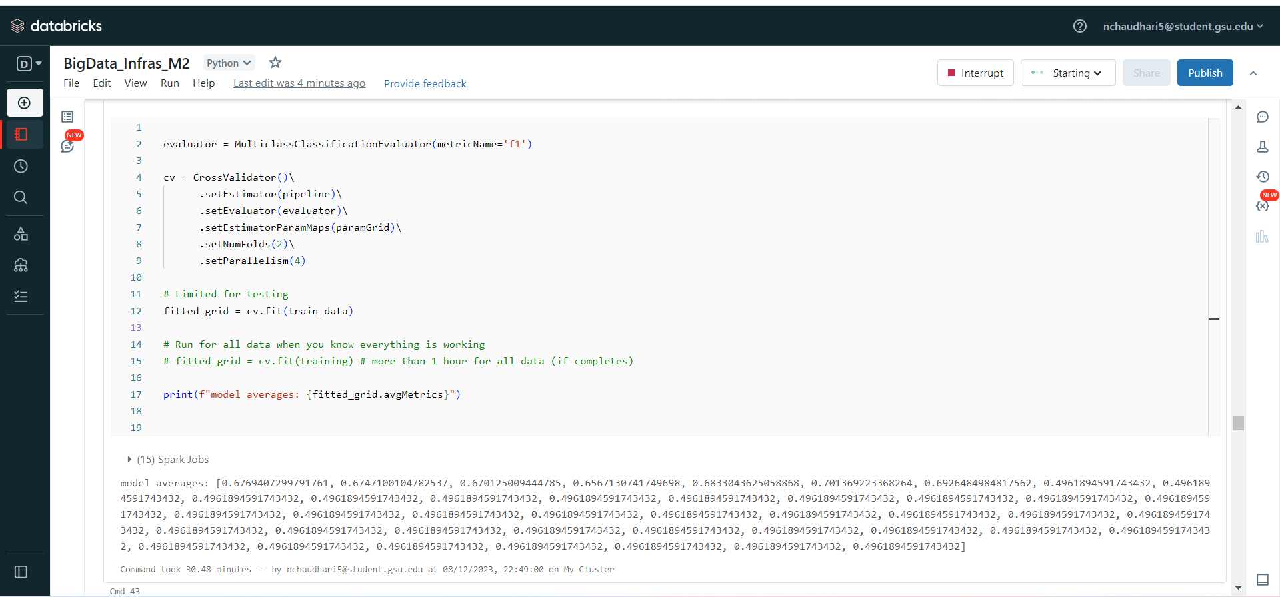

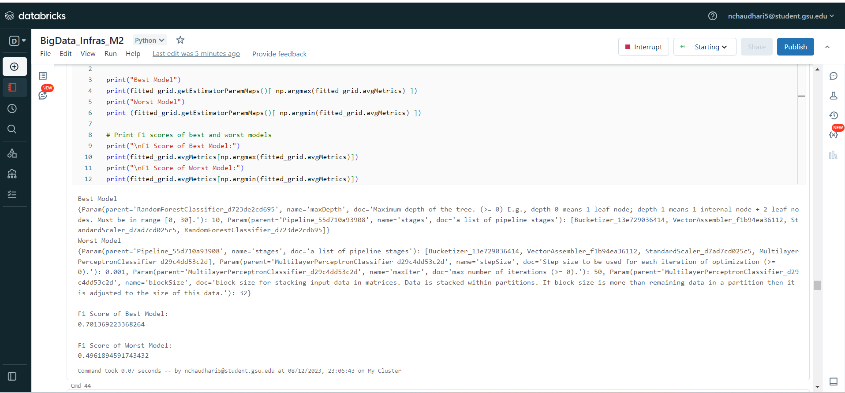

Model 8: {Param(parent='Pipeline_55d710a93908', name='stages', doc='a list of pipeline stages'): [Bucketizer_13e729036414, VectorAssembler_f1b94ea36112, StandardScaler_d7ad7cd025c5, MultilayerPerceptronClassifier_d29c4dd53c2d], Param(parent='MultilayerPerceptronClassifier_d29c4dd53c2d', name='stepSize', doc='Step size to be used for each iteration of optimization (>= 0).'): 0.001, Param(parent='MultilayerPerceptronClassifier_d29c4dd53c2d', name='maxIter', doc='max number of iterations (>= 0).'): 50, Param(parent='MultilayerPerceptronClassifier_d29c4dd53c2d', name='blockSize', doc='block size for stacking input data in matrices. Data is stacked within partitions. If block size is more than remaining data in a partition then it is adjusted to the size of this data.'): 32}

F1 Score: 0.4961894591743432

Model 9: {Param(parent='Pipeline_55d710a93908', name='stages', doc='a list of pipeline stages'): [Bucketizer_13e729036414, VectorAssembler_f1b94ea36112, StandardScaler_d7ad7cd025c5, MultilayerPerceptronClassifier_d29c4dd53c2d], Param(parent='MultilayerPerceptronClassifier_d29c4dd53c2d', name='stepSize', doc='Step size to be used for each iteration of optimization (>= 0).'): 0.001, Param(parent='MultilayerPerceptronClassifier_d29c4dd53c2d', name='maxIter', doc='max number of iterations (>= 0).'): 50, Param(parent='MultilayerPerceptronClassifier_d29c4dd53c2d', name='blockSize', doc='block size for stacking input data in matrices. Data is stacked within partitions. If block size is more than remaining data in a partition then it is adjusted to the size of this data.'): 64}

F1 Score: 0.4961894591743432

Model 10: {Param(parent='Pipeline_55d710a93908', name='stages', doc='a list of pipeline stages'): [Bucketizer_13e729036414, VectorAssembler_f1b94ea36112, StandardScaler_d7ad7cd025c5, MultilayerPerceptronClassifier_d29c4dd53c2d], Param(parent='MultilayerPerceptronClassifier_d29c4dd53c2d', name='stepSize', doc='Step size to be used for each iteration of optimization (>= 0).'): 0.001, Param(parent='MultilayerPerceptronClassifier_d29c4dd53c2d', name='maxIter', doc='max number of iterations (>= 0).'): 50, Param(parent='MultilayerPerceptronClassifier_d29c4dd53c2d', name='blockSize', doc='block size for stacking input data in matrices. Data is stacked within partitions. If block size is more than remaining data in a partition then it is adjusted to the size of this data.'): 128}

F1 Score: 0.4961894591743432

Model 11: {Param(parent='Pipeline_55d710a93908', name='stages', doc='a list of pipeline stages'): [Bucketizer_13e729036414, VectorAssembler_f1b94ea36112, StandardScaler_d7ad7cd025c5, MultilayerPerceptronClassifier_d29c4dd53c2d], Param(parent='MultilayerPerceptronClassifier_d29c4dd53c2d', name='stepSize', doc='Step size to be used for each iteration of optimization (>= 0).'): 0.001, Param(parent='MultilayerPerceptronClassifier_d29c4dd53c2d', name='maxIter', doc='max number of iterations (>= 0).'): 100, Param(parent='MultilayerPerceptronClassifier_d29c4dd53c2d', name='blockSize', doc='block size for stacking input data in matrices. Data is stacked within partitions. If block size is more than remaining data in a partition then it is adjusted to the size of this data.'): 32}

F1 Score: 0.4961894591743432

Model 12: {Param(parent='Pipeline_55d710a93908', name='stages', doc='a list of pipeline stages'): [Bucketizer_13e729036414, VectorAssembler_f1b94ea36112, StandardScaler_d7ad7cd025c5, MultilayerPerceptronClassifier_d29c4dd53c2d], Param(parent='MultilayerPerceptronClassifier_d29c4dd53c2d', name='stepSize', doc='Step size to be used for each iteration of optimization (>= 0).'): 0.001, Param(parent='MultilayerPerceptronClassifier_d29c4dd53c2d', name='maxIter', doc='max number of iterations (>= 0).'): 100, Param(parent='MultilayerPerceptronClassifier_d29c4dd53c2d', name='blockSize', doc='block size for stacking input data in matrices. Data is stacked within partitions. If block size is more than remaining data in a partition then it is adjusted to the size of this data.'): 64}

F1 Score: 0.4961894591743432

Model 13: {Param(parent='Pipeline_55d710a93908', name='stages', doc='a list of pipeline stages'): [Bucketizer_13e729036414, VectorAssembler_f1b94ea36112, StandardScaler_d7ad7cd025c5, MultilayerPerceptronClassifier_d29c4dd53c2d], Param(parent='MultilayerPerceptronClassifier_d29c4dd53c2d', name='stepSize', doc='Step size to be used for each iteration of optimization (>= 0).'): 0.001, Param(parent='MultilayerPerceptronClassifier_d29c4dd53c2d', name='maxIter', doc='max number of iterations (>= 0).'): 100, Param(parent='MultilayerPerceptronClassifier_d29c4dd53c2d', name='blockSize', doc='block size for stacking input data in matrices. Data is stacked within partitions. If block size is more than remaining data in a partition then it is adjusted to the size of this data.'): 128}

F1 Score: 0.4961894591743432

Model 14: {Param(parent='Pipeline_55d710a93908', name='stages', doc='a list of pipeline stages'): [Bucketizer_13e729036414, VectorAssembler_f1b94ea36112, StandardScaler_d7ad7cd025c5, MultilayerPerceptronClassifier_d29c4dd53c2d], Param(parent='MultilayerPerceptronClassifier_d29c4dd53c2d', name='stepSize', doc='Step size to be used for each iteration of optimization (>= 0).'): 0.001, Param(parent='MultilayerPerceptronClassifier_d29c4dd53c2d', name='maxIter', doc='max number of iterations (>= 0).'): 150, Param(parent='MultilayerPerceptronClassifier_d29c4dd53c2d', name='blockSize', doc='block size for stacking input data in matrices. Data is stacked within partitions. If block size is more than remaining data in a partition then it is adjusted to the size of this data.'): 32}

F1 Score: 0.4961894591743432

Model 15: {Param(parent='Pipeline_55d710a93908', name='stages', doc='a list of pipeline stages'): [Bucketizer_13e729036414, VectorAssembler_f1b94ea36112, StandardScaler_d7ad7cd025c5, MultilayerPerceptronClassifier_d29c4dd53c2d], Param(parent='MultilayerPerceptronClassifier_d29c4dd53c2d', name='stepSize', doc='Step size to be used for each iteration of optimization (>= 0).'): 0.001, Param(parent='MultilayerPerceptronClassifier_d29c4dd53c2d', name='maxIter', doc='max number of iterations (>= 0).'): 150, Param(parent='MultilayerPerceptronClassifier_d29c4dd53c2d', name='blockSize', doc='block size for stacking input data in matrices. Data is stacked within partitions. If block size is more than remaining data in a partition then it is adjusted to the size of this data.'): 64}

F1 Score: 0.4961894591743432

Model 16: {Param(parent='Pipeline_55d710a93908', name='stages', doc='a list of pipeline stages'): [Bucketizer_13e729036414, VectorAssembler_f1b94ea36112, StandardScaler_d7ad7cd025c5, MultilayerPerceptronClassifier_d29c4dd53c2d], Param(parent='MultilayerPerceptronClassifier_d29c4dd53c2d', name='stepSize', doc='Step size to be used for each iteration of optimization (>= 0).'): 0.001, Param(parent='MultilayerPerceptronClassifier_d29c4dd53c2d', name='maxIter', doc='max number of iterations (>= 0).'): 150, Param(parent='MultilayerPerceptronClassifier_d29c4dd53c2d', name='blockSize', doc='block size for stacking input data in matrices. Data is stacked within partitions. If block size is more than remaining data in a partition then it is adjusted to the size of this data.'): 128}

F1 Score: 0.4961894591743432

Model 17: {Param(parent='Pipeline_55d710a93908', name='stages', doc='a list of pipeline stages'): [Bucketizer_13e729036414, VectorAssembler_f1b94ea36112, StandardScaler_d7ad7cd025c5, MultilayerPerceptronClassifier_d29c4dd53c2d], Param(parent='MultilayerPerceptronClassifier_d29c4dd53c2d', name='stepSize', doc='Step size to be used for each iteration of optimization (>= 0).'): 0.01, Param(parent='MultilayerPerceptronClassifier_d29c4dd53c2d', name='maxIter', doc='max number of iterations (>= 0).'): 50, Param(parent='MultilayerPerceptronClassifier_d29c4dd53c2d', name='blockSize', doc='block size for stacking input data in matrices. Data is stacked within partitions. If block size is more than remaining data in a partition then it is adjusted to the size of this data.'): 32}

F1 Score: 0.4961894591743432

Model 18: {Param(parent='Pipeline_55d710a93908', name='stages', doc='a list of pipeline stages'): [Bucketizer_13e729036414, VectorAssembler_f1b94ea36112, StandardScaler_d7ad7cd025c5, MultilayerPerceptronClassifier_d29c4dd53c2d], Param(parent='MultilayerPerceptronClassifier_d29c4dd53c2d', name='stepSize', doc='Step size to be used for each iteration of optimization (>= 0).'): 0.01, Param(parent='MultilayerPerceptronClassifier_d29c4dd53c2d', name='maxIter', doc='max number of iterations (>= 0).'): 50, Param(parent='MultilayerPerceptronClassifier_d29c4dd53c2d', name='blockSize', doc='block size for stacking input data in matrices. Data is stacked within partitions. If block size is more than remaining data in a partition then it is adjusted to the size of this data.'): 64}

F1 Score: 0.4961894591743432

Model 19: {Param(parent='Pipeline_55d710a93908', name='stages', doc='a list of pipeline stages'): [Bucketizer_13e729036414, VectorAssembler_f1b94ea36112, StandardScaler_d7ad7cd025c5, MultilayerPerceptronClassifier_d29c4dd53c2d], Param(parent='MultilayerPerceptronClassifier_d29c4dd53c2d', name='stepSize', doc='Step size to be used for each iteration of optimization (>= 0).'): 0.01, Param(parent='MultilayerPerceptronClassifier_d29c4dd53c2d', name='maxIter', doc='max number of iterations (>= 0).'): 50, Param(parent='MultilayerPerceptronClassifier_d29c4dd53c2d', name='blockSize', doc='block size for stacking input data in matrices. Data is stacked within partitions. If block size is more than remaining data in a partition then it is adjusted to the size of this data.'): 128}

F1 Score: 0.4961894591743432

Model 20: {Param(parent='Pipeline_55d710a93908', name='stages', doc='a list of pipeline stages'): [Bucketizer_13e729036414, VectorAssembler_f1b94ea36112, StandardScaler_d7ad7cd025c5, MultilayerPerceptronClassifier_d29c4dd53c2d], Param(parent='MultilayerPerceptronClassifier_d29c4dd53c2d', name='stepSize', doc='Step size to be used for each iteration of optimization (>= 0).'): 0.01, Param(parent='MultilayerPerceptronClassifier_d29c4dd53c2d', name='maxIter', doc='max number of iterations (>= 0).'): 100, Param(parent='MultilayerPerceptronClassifier_d29c4dd53c2d', name='blockSize', doc='block size for stacking input data in matrices. Data is stacked within partitions. If block size is more than remaining data in a partition then it is adjusted to the size of this data.'): 32}

F1 Score: 0.4961894591743432

Model 21: {Param(parent='Pipeline_55d710a93908', name='stages', doc='a list of pipeline stages'): [Bucketizer_13e729036414, VectorAssembler_f1b94ea36112, StandardScaler_d7ad7cd025c5, MultilayerPerceptronClassifier_d29c4dd53c2d], Param(parent='MultilayerPerceptronClassifier_d29c4dd53c2d', name='stepSize', doc='Step size to be used for each iteration of optimization (>= 0).'): 0.01, Param(parent='MultilayerPerceptronClassifier_d29c4dd53c2d', name='maxIter', doc='max number of iterations (>= 0).'): 100, Param(parent='MultilayerPerceptronClassifier_d29c4dd53c2d', name='blockSize', doc='block size for stacking input data in matrices. Data is stacked within partitions. If block size is more than remaining data in a partition then it is adjusted to the size of this data.'): 64}

F1 Score: 0.4961894591743432

Model 22: {Param(parent='Pipeline_55d710a93908', name='stages', doc='a list of pipeline stages'): [Bucketizer_13e729036414, VectorAssembler_f1b94ea36112, StandardScaler_d7ad7cd025c5, MultilayerPerceptronClassifier_d29c4dd53c2d], Param(parent='MultilayerPerceptronClassifier_d29c4dd53c2d', name='stepSize', doc='Step size to be used for each iteration of optimization (>= 0).'): 0.01, Param(parent='MultilayerPerceptronClassifier_d29c4dd53c2d', name='maxIter', doc='max number of iterations (>= 0).'): 100, Param(parent='MultilayerPerceptronClassifier_d29c4dd53c2d', name='blockSize', doc='block size for stacking input data in matrices. Data is stacked within partitions. If block size is more than remaining data in a partition then it is adjusted to the size of this data.'): 128}

F1 Score: 0.4961894591743432

Model 23: {Param(parent='Pipeline_55d710a93908', name='stages', doc='a list of pipeline stages'): [Bucketizer_13e729036414, VectorAssembler_f1b94ea36112, StandardScaler_d7ad7cd025c5, MultilayerPerceptronClassifier_d29c4dd53c2d], Param(parent='MultilayerPerceptronClassifier_d29c4dd53c2d', name='stepSize', doc='Step size to be used for each iteration of optimization (>= 0).'): 0.01, Param(parent='MultilayerPerceptronClassifier_d29c4dd53c2d', name='maxIter', doc='max number of iterations (>= 0).'): 150, Param(parent='MultilayerPerceptronClassifier_d29c4dd53c2d', name='blockSize', doc='block size for stacking input data in matrices. Data is stacked within partitions. If block size is more than remaining data in a partition then it is adjusted to the size of this data.'): 32}

F1 Score: 0.4961894591743432

Model 24: {Param(parent='Pipeline_55d710a93908', name='stages', doc='a list of pipeline stages'): [Bucketizer_13e729036414, VectorAssembler_f1b94ea36112, StandardScaler_d7ad7cd025c5, MultilayerPerceptronClassifier_d29c4dd53c2d], Param(parent='MultilayerPerceptronClassifier_d29c4dd53c2d', name='stepSize', doc='Step size to be used for each iteration of optimization (>= 0).'): 0.01, Param(parent='MultilayerPerceptronClassifier_d29c4dd53c2d', name='maxIter', doc='max number of iterations (>= 0).'): 150, Param(parent='MultilayerPerceptronClassifier_d29c4dd53c2d', name='blockSize', doc='block size for stacking input data in matrices. Data is stacked within partitions. If block size is more than remaining data in a partition then it is adjusted to the size of this data.'): 64}

F1 Score: 0.4961894591743432

Model 25: {Param(parent='Pipeline_55d710a93908', name='stages', doc='a list of pipeline stages'): [Bucketizer_13e729036414, VectorAssembler_f1b94ea36112, StandardScaler_d7ad7cd025c5, MultilayerPerceptronClassifier_d29c4dd53c2d], Param(parent='MultilayerPerceptronClassifier_d29c4dd53c2d', name='stepSize', doc='Step size to be used for each iteration of optimization (>= 0).'): 0.01, Param(parent='MultilayerPerceptronClassifier_d29c4dd53c2d', name='maxIter', doc='max number of iterations (>= 0).'): 150, Param(parent='MultilayerPerceptronClassifier_d29c4dd53c2d', name='blockSize', doc='block size for stacking input data in matrices. Data is stacked within partitions. If block size is more than remaining data in a partition then it is adjusted to the size of this data.'): 128}

F1 Score: 0.4961894591743432

Model 26: {Param(parent='Pipeline_55d710a93908', name='stages', doc='a list of pipeline stages'): [Bucketizer_13e729036414, VectorAssembler_f1b94ea36112, StandardScaler_d7ad7cd025c5, MultilayerPerceptronClassifier_d29c4dd53c2d], Param(parent='MultilayerPerceptronClassifier_d29c4dd53c2d', name='stepSize', doc='Step size to be used for each iteration of optimization (>= 0).'): 0.03, Param(parent='MultilayerPerceptronClassifier_d29c4dd53c2d', name='maxIter', doc='max number of iterations (>= 0).'): 50, Param(parent='MultilayerPerceptronClassifier_d29c4dd53c2d', name='blockSize', doc='block size for stacking input data in matrices. Data is stacked within partitions. If block size is more than remaining data in a partition then it is adjusted to the size of this data.'): 32}

F1 Score: 0.4961894591743432

Model 27: {Param(parent='Pipeline_55d710a93908', name='stages', doc='a list of pipeline stages'): [Bucketizer_13e729036414, VectorAssembler_f1b94ea36112, StandardScaler_d7ad7cd025c5, MultilayerPerceptronClassifier_d29c4dd53c2d], Param(parent='MultilayerPerceptronClassifier_d29c4dd53c2d', name='stepSize', doc='Step size to be used for each iteration of optimization (>= 0).'): 0.03, Param(parent='MultilayerPerceptronClassifier_d29c4dd53c2d', name='maxIter', doc='max number of iterations (>= 0).'): 50, Param(parent='MultilayerPerceptronClassifier_d29c4dd53c2d', name='blockSize', doc='block size for stacking input data in matrices. Data is stacked within partitions. If block size is more than remaining data in a partition then it is adjusted to the size of this data.'): 64}

F1 Score: 0.4961894591743432

Model 28: {Param(parent='Pipeline_55d710a93908', name='stages', doc='a list of pipeline stages'): [Bucketizer_13e729036414, VectorAssembler_f1b94ea36112, StandardScaler_d7ad7cd025c5, MultilayerPerceptronClassifier_d29c4dd53c2d], Param(parent='MultilayerPerceptronClassifier_d29c4dd53c2d', name='stepSize', doc='Step size to be used for each iteration of optimization (>= 0).'): 0.03, Param(parent='MultilayerPerceptronClassifier_d29c4dd53c2d', name='maxIter', doc='max number of iterations (>= 0).'): 50, Param(parent='MultilayerPerceptronClassifier_d29c4dd53c2d', name='blockSize', doc='block size for stacking input data in matrices. Data is stacked within partitions. If block size is more than remaining data in a partition then it is adjusted to the size of this data.'): 128}

F1 Score: 0.4961894591743432

Model 29: {Param(parent='Pipeline_55d710a93908', name='stages', doc='a list of pipeline stages'): [Bucketizer_13e729036414, VectorAssembler_f1b94ea36112, StandardScaler_d7ad7cd025c5, MultilayerPerceptronClassifier_d29c4dd53c2d], Param(parent='MultilayerPerceptronClassifier_d29c4dd53c2d', name='stepSize', doc='Step size to be used for each iteration of optimization (>= 0).'): 0.03, Param(parent='MultilayerPerceptronClassifier_d29c4dd53c2d', name='maxIter', doc='max number of iterations (>= 0).'): 100, Param(parent='MultilayerPerceptronClassifier_d29c4dd53c2d', name='blockSize', doc='block size for stacking input data in matrices. Data is stacked within partitions. If block size is more than remaining data in a partition then it is adjusted to the size of this data.'): 32}

F1 Score: 0.4961894591743432

Model 30: {Param(parent='Pipeline_55d710a93908', name='stages', doc='a list of pipeline stages'): [Bucketizer_13e729036414, VectorAssembler_f1b94ea36112, StandardScaler_d7ad7cd025c5, MultilayerPerceptronClassifier_d29c4dd53c2d], Param(parent='MultilayerPerceptronClassifier_d29c4dd53c2d', name='stepSize', doc='Step size to be used for each iteration of optimization (>= 0).'): 0.03, Param(parent='MultilayerPerceptronClassifier_d29c4dd53c2d', name='maxIter', doc='max number of iterations (>= 0).'): 100, Param(parent='MultilayerPerceptronClassifier_d29c4dd53c2d', name='blockSize', doc='block size for stacking input data in matrices. Data is stacked within partitions. If block size is more than remaining data in a partition then it is adjusted to the size of this data.'): 64}

F1 Score: 0.4961894591743432

Model 31: {Param(parent='Pipeline_55d710a93908', name='stages', doc='a list of pipeline stages'): [Bucketizer_13e729036414, VectorAssembler_f1b94ea36112, StandardScaler_d7ad7cd025c5, MultilayerPerceptronClassifier_d29c4dd53c2d], Param(parent='MultilayerPerceptronClassifier_d29c4dd53c2d', name='stepSize', doc='Step size to be used for each iteration of optimization (>= 0).'): 0.03, Param(parent='MultilayerPerceptronClassifier_d29c4dd53c2d', name='maxIter', doc='max number of iterations (>= 0).'): 100, Param(parent='MultilayerPerceptronClassifier_d29c4dd53c2d', name='blockSize', doc='block size for stacking input data in matrices. Data is stacked within partitions. If block size is more than remaining data in a partition then it is adjusted to the size of this data.'): 128}

F1 Score: 0.4961894591743432

Model 32: {Param(parent='Pipeline_55d710a93908', name='stages', doc='a list of pipeline stages'): [Bucketizer_13e729036414, VectorAssembler_f1b94ea36112, StandardScaler_d7ad7cd025c5, MultilayerPerceptronClassifier_d29c4dd53c2d], Param(parent='MultilayerPerceptronClassifier_d29c4dd53c2d', name='stepSize', doc='Step size to be used for each iteration of optimization (>= 0).'): 0.03, Param(parent='MultilayerPerceptronClassifier_d29c4dd53c2d', name='maxIter', doc='max number of iterations (>= 0).'): 150, Param(parent='MultilayerPerceptronClassifier_d29c4dd53c2d', name='blockSize', doc='block size for stacking input data in matrices. Data is stacked within partitions. If block size is more than remaining data in a partition then it is adjusted to the size of this data.'): 32}

F1 Score: 0.4961894591743432

Model 33: {Param(parent='Pipeline_55d710a93908', name='stages', doc='a list of pipeline stages'): [Bucketizer_13e729036414, VectorAssembler_f1b94ea36112, StandardScaler_d7ad7cd025c5, MultilayerPerceptronClassifier_d29c4dd53c2d], Param(parent='MultilayerPerceptronClassifier_d29c4dd53c2d', name='stepSize', doc='Step size to be used for each iteration of optimization (>= 0).'): 0.03, Param(parent='MultilayerPerceptronClassifier_d29c4dd53c2d', name='maxIter', doc='max number of iterations (>= 0).'): 150, Param(parent='MultilayerPerceptronClassifier_d29c4dd53c2d', name='blockSize', doc='block size for stacking input data in matrices. Data is stacked within partitions. If block size is more than remaining data in a partition then it is adjusted to the size of this data.'): 64}

F1 Score: 0.4961894591743432

Model 34: {Param(parent='Pipeline_55d710a93908', name='stages', doc='a list of pipeline stages'): [Bucketizer_13e729036414, VectorAssembler_f1b94ea36112, StandardScaler_d7ad7cd025c5, MultilayerPerceptronClassifier_d29c4dd53c2d], Param(parent='MultilayerPerceptronClassifier_d29c4dd53c2d', name='stepSize', doc='Step size to be used for each iteration of optimization (>= 0).'): 0.03, Param(parent='MultilayerPerceptronClassifier_d29c4dd53c2d', name='maxIter', doc='max number of iterations (>= 0).'): 150, Param(parent='MultilayerPerceptronClassifier_d29c4dd53c2d', name='blockSize', doc='block size for stacking input data in matrices. Data is stacked within partitions. If block size is more than remaining data in a partition then it is adjusted to the size of this data.'): 128}

F1 Score: 0.4961894591743432

Model 35: {Param(parent='Pipeline_55d710a93908', name='stages', doc='a list of pipeline stages'): [Bucketizer_13e729036414, VectorAssembler_f1b94ea36112, StandardScaler_d7ad7cd025c5, MultilayerPerceptronClassifier_d29c4dd53c2d], Param(parent='MultilayerPerceptronClassifier_d29c4dd53c2d', name='stepSize', doc='Step size to be used for each iteration of optimization (>= 0).'): 0.1, Param(parent='MultilayerPerceptronClassifier_d29c4dd53c2d', name='maxIter', doc='max number of iterations (>= 0).'): 50, Param(parent='MultilayerPerceptronClassifier_d29c4dd53c2d', name='blockSize', doc='block size for stacking input data in matrices. Data is stacked within partitions. If block size is more than remaining data in a partition then it is adjusted to the size of this data.'): 32}

F1 Score: 0.4961894591743432

Model 36: {Param(parent='Pipeline_55d710a93908', name='stages', doc='a list of pipeline stages'): [Bucketizer_13e729036414, VectorAssembler_f1b94ea36112, StandardScaler_d7ad7cd025c5, MultilayerPerceptronClassifier_d29c4dd53c2d], Param(parent='MultilayerPerceptronClassifier_d29c4dd53c2d', name='stepSize', doc='Step size to be used for each iteration of optimization (>= 0).'): 0.1, Param(parent='MultilayerPerceptronClassifier_d29c4dd53c2d', name='maxIter', doc='max number of iterations (>= 0).'): 50, Param(parent='MultilayerPerceptronClassifier_d29c4dd53c2d', name='blockSize', doc='block size for stacking input data in matrices. Data is stacked within partitions. If block size is more than remaining data in a partition then it is adjusted to the size of this data.'): 64}

F1 Score: 0.4961894591743432

Model 37: {Param(parent='Pipeline_55d710a93908', name='stages', doc='a list of pipeline stages'): [Bucketizer_13e729036414, VectorAssembler_f1b94ea36112, StandardScaler_d7ad7cd025c5, MultilayerPerceptronClassifier_d29c4dd53c2d], Param(parent='MultilayerPerceptronClassifier_d29c4dd53c2d', name='stepSize', doc='Step size to be used for each iteration of optimization (>= 0).'): 0.1, Param(parent='MultilayerPerceptronClassifier_d29c4dd53c2d', name='maxIter', doc='max number of iterations (>= 0).'): 50, Param(parent='MultilayerPerceptronClassifier_d29c4dd53c2d', name='blockSize', doc='block size for stacking input data in matrices. Data is stacked within partitions. If block size is more than remaining data in a partition then it is adjusted to the size of this data.'): 128}

F1 Score: 0.4961894591743432

Model 38: {Param(parent='Pipeline_55d710a93908', name='stages', doc='a list of pipeline stages'): [Bucketizer_13e729036414, VectorAssembler_f1b94ea36112, StandardScaler_d7ad7cd025c5, MultilayerPerceptronClassifier_d29c4dd53c2d], Param(parent='MultilayerPerceptronClassifier_d29c4dd53c2d', name='stepSize', doc='Step size to be used for each iteration of optimization (>= 0).'): 0.1, Param(parent='MultilayerPerceptronClassifier_d29c4dd53c2d', name='maxIter', doc='max number of iterations (>= 0).'): 100, Param(parent='MultilayerPerceptronClassifier_d29c4dd53c2d', name='blockSize', doc='block size for stacking input data in matrices. Data is stacked within partitions. If block size is more than remaining data in a partition then it is adjusted to the size of this data.'): 32}

F1 Score: 0.4961894591743432

Model 39: {Param(parent='Pipeline_55d710a93908', name='stages', doc='a list of pipeline stages'): [Bucketizer_13e729036414, VectorAssembler_f1b94ea36112, StandardScaler_d7ad7cd025c5, MultilayerPerceptronClassifier_d29c4dd53c2d], Param(parent='MultilayerPerceptronClassifier_d29c4dd53c2d', name='stepSize', doc='Step size to be used for each iteration of optimization (>= 0).'): 0.1, Param(parent='MultilayerPerceptronClassifier_d29c4dd53c2d', name='maxIter', doc='max number of iterations (>= 0).'): 100, Param(parent='MultilayerPerceptronClassifier_d29c4dd53c2d', name='blockSize', doc='block size for stacking input data in matrices. Data is stacked within partitions. If block size is more than remaining data in a partition then it is adjusted to the size of this data.'): 64}

F1 Score: 0.4961894591743432

Model 40: {Param(parent='Pipeline_55d710a93908', name='stages', doc='a list of pipeline stages'): [Bucketizer_13e729036414, VectorAssembler_f1b94ea36112, StandardScaler_d7ad7cd025c5, MultilayerPerceptronClassifier_d29c4dd53c2d], Param(parent='MultilayerPerceptronClassifier_d29c4dd53c2d', name='stepSize', doc='Step size to be used for each iteration of optimization (>= 0).'): 0.1, Param(parent='MultilayerPerceptronClassifier_d29c4dd53c2d', name='maxIter', doc='max number of iterations (>= 0).'): 100, Param(parent='MultilayerPerceptronClassifier_d29c4dd53c2d', name='blockSize', doc='block size for stacking input data in matrices. Data is stacked within partitions. If block size is more than remaining data in a partition then it is adjusted to the size of this data.'): 128}

F1 Score: 0.4961894591743432

Model 41: {Param(parent='Pipeline_55d710a93908', name='stages', doc='a list of pipeline stages'): [Bucketizer_13e729036414, VectorAssembler_f1b94ea36112, StandardScaler_d7ad7cd025c5, MultilayerPerceptronClassifier_d29c4dd53c2d], Param(parent='MultilayerPerceptronClassifier_d29c4dd53c2d', name='stepSize', doc='Step size to be used for each iteration of optimization (>= 0).'): 0.1, Param(parent='MultilayerPerceptronClassifier_d29c4dd53c2d', name='maxIter', doc='max number of iterations (>= 0).'): 150, Param(parent='MultilayerPerceptronClassifier_d29c4dd53c2d', name='blockSize', doc='block size for stacking input data in matrices. Data is stacked within partitions. If block size is more than remaining data in a partition then it is adjusted to the size of this data.'): 32}

F1 Score: 0.4961894591743432

Model 42: {Param(parent='Pipeline_55d710a93908', name='stages', doc='a list of pipeline stages'): [Bucketizer_13e729036414, VectorAssembler_f1b94ea36112, StandardScaler_d7ad7cd025c5, MultilayerPerceptronClassifier_d29c4dd53c2d], Param(parent='MultilayerPerceptronClassifier_d29c4dd53c2d', name='stepSize', doc='Step size to be used for each iteration of optimization (>= 0).'): 0.1, Param(parent='MultilayerPerceptronClassifier_d29c4dd53c2d', name='maxIter', doc='max number of iterations (>= 0).'): 150, Param(parent='MultilayerPerceptronClassifier_d29c4dd53c2d', name='blockSize', doc='block size for stacking input data in matrices. Data is stacked within partitions. If block size is more than remaining data in a partition then it is adjusted to the size of this data.'): 64}

F1 Score: 0.4961894591743432

Model 43: {Param(parent='Pipeline_55d710a93908', name='stages', doc='a list of pipeline stages'): [Bucketizer_13e729036414, VectorAssembler_f1b94ea36112, StandardScaler_d7ad7cd025c5, MultilayerPerceptronClassifier_d29c4dd53c2d], Param(parent='MultilayerPerceptronClassifier_d29c4dd53c2d', name='stepSize', doc='Step size to be used for each iteration of optimization (>= 0).'): 0.1, Param(parent='MultilayerPerceptronClassifier_d29c4dd53c2d', name='maxIter', doc='max number of iterations (>= 0).'): 150, Param(parent='MultilayerPerceptronClassifier_d29c4dd53c2d', name='blockSize', doc='block size for stacking input data in matrices. Data is stacked within partitions. If block size is more than remaining data in a partition then it is adjusted to the size of this data.'): 128}

F1 Score: 0.4961894591743432